Xiaoru Chen

chenxia2@oregonstate.edu

Project #1

CS 475/575

2021-04-16

**Table:**

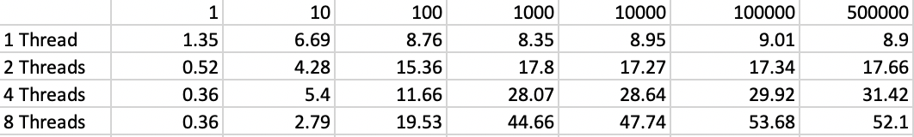

Fig. 1.1 Monte Carlo Performance table.

**Graphs:**

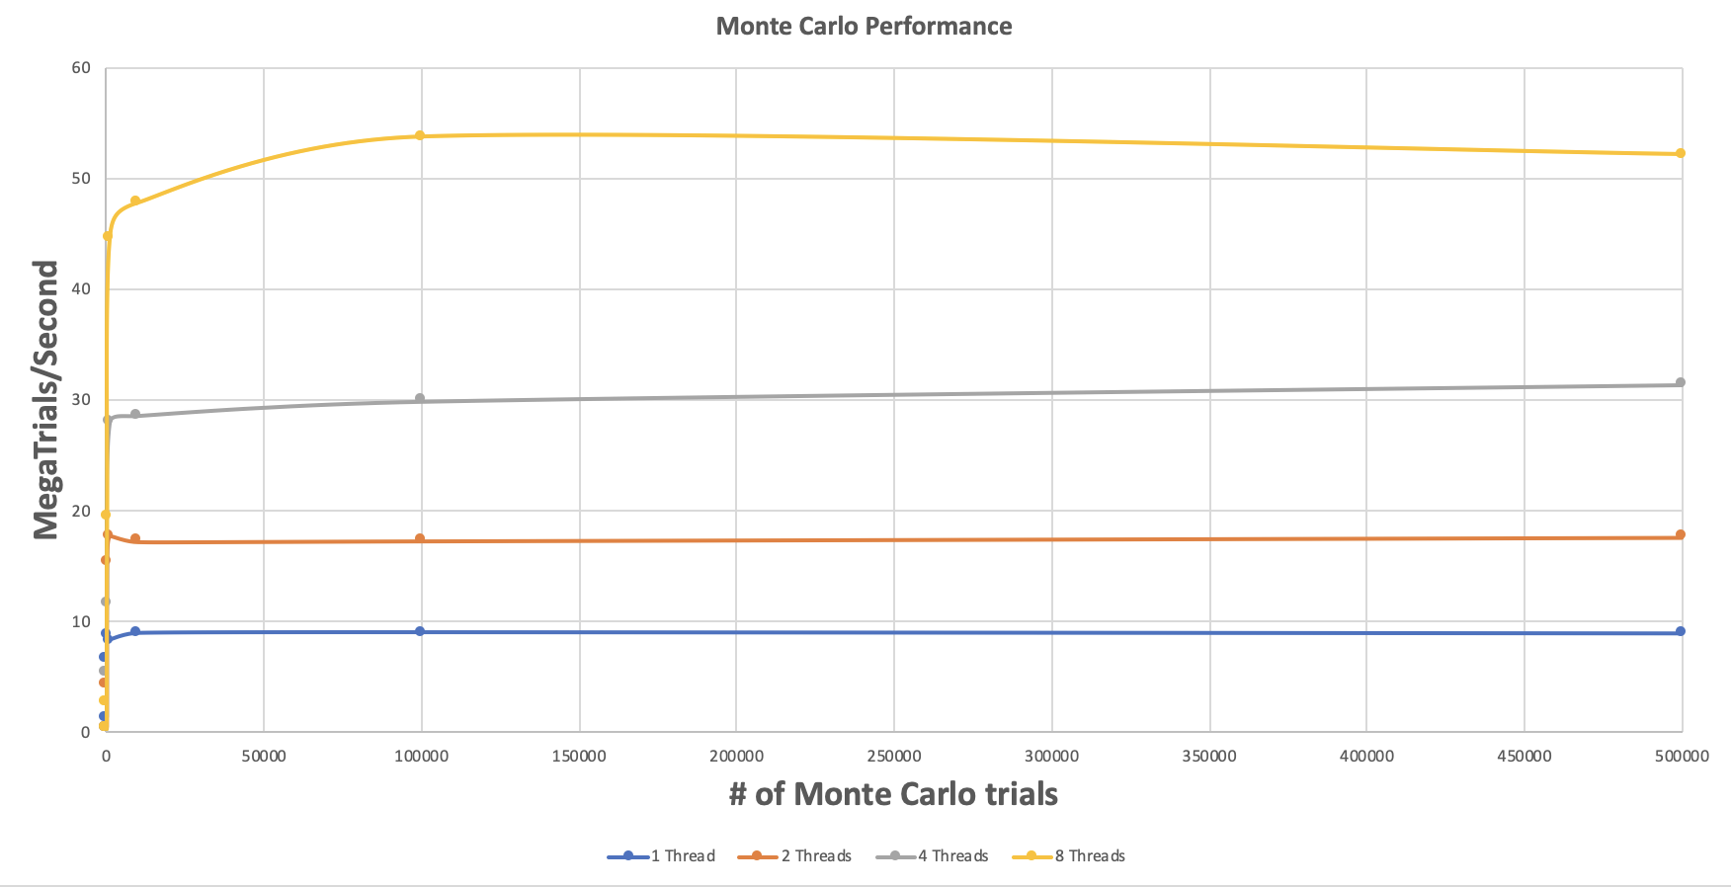

Fig. 1.2 Graph of performance vs. number of trials

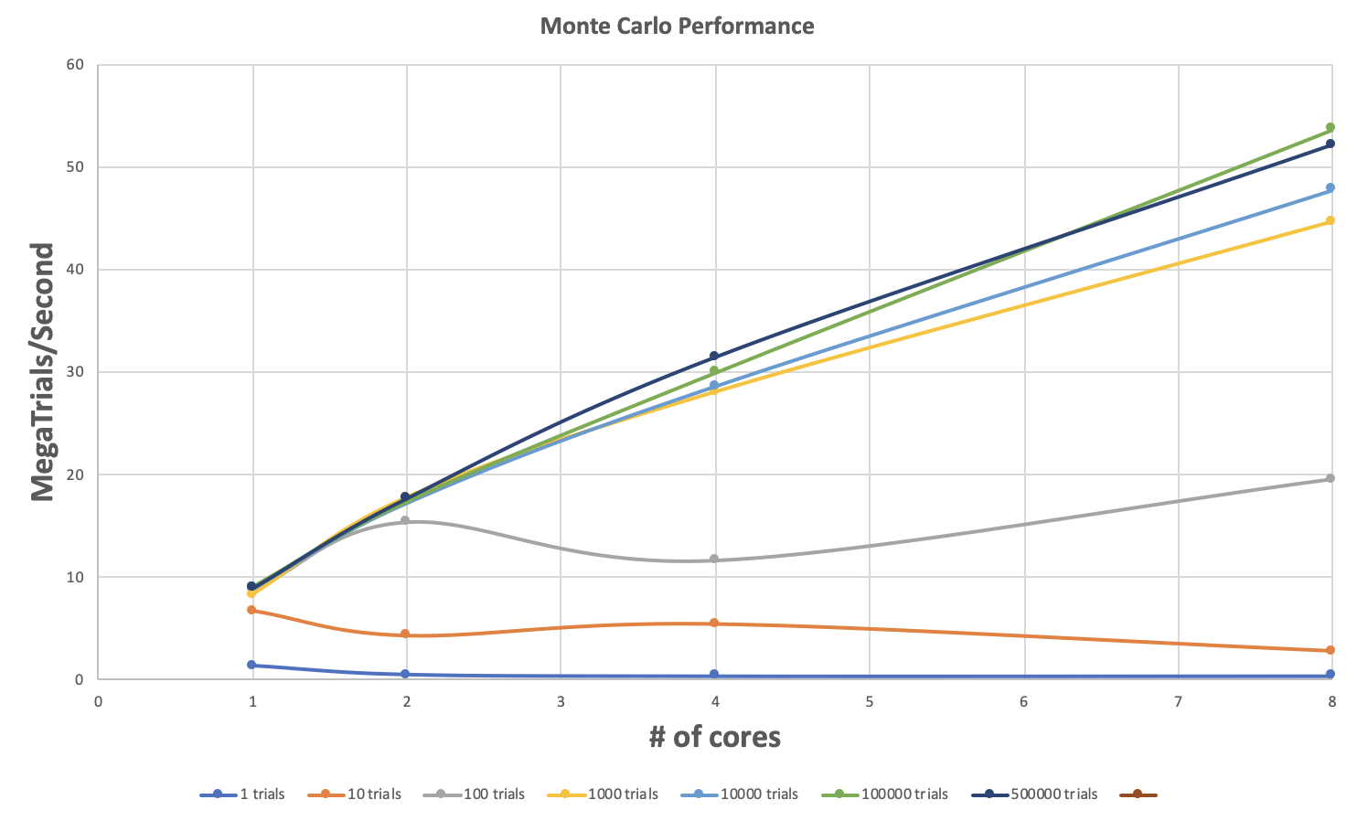

Fig. 1.3 Graph of performance vs. number of threads.

**Estimate of the actual probability:**

Results:

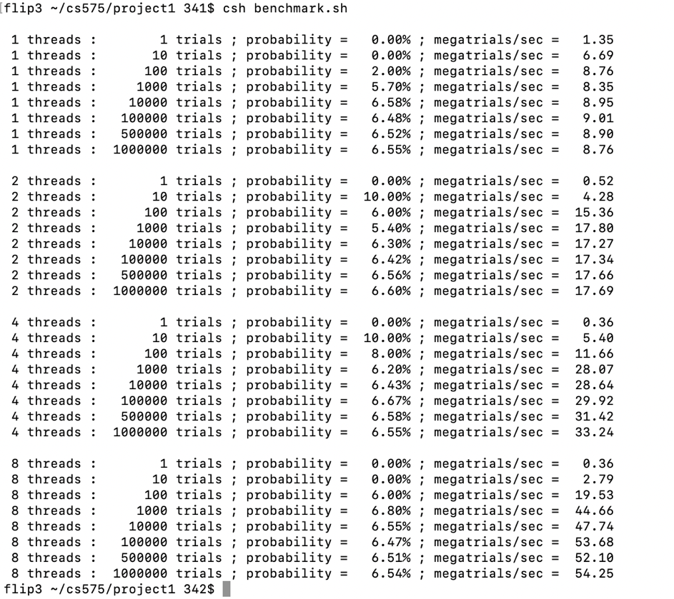

Based on the results here, choose the run with the maximum number of trials and 8 threads, the actual probability should be 6.54%.

**Compute Fp:**